Aswin S

A detail on how to raise a database patch, guidelines to follow while creating them and the naming convention to use for the patch filename.

Phase2 – Database Patches

Walkthrough

**Contents**

**How to raise a patch: 1**

**Patch creation guidelines: 1**

**Patch filename guidelines: 3**

# **SLMS2 - Database Patches**

# **How to raise a patch:**

Below is the Project and Issue type to be selected when you need to raise a ticket for a database patch.

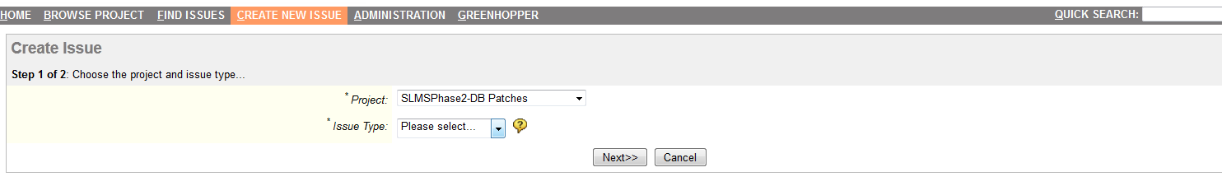

Also, while you raise a patch please keep in mind and follow the below guidelines, without which a patch maybe be rejected.

# **Patch creation guidelines:**

1. No semi colons after a SQL (ANT does not recognise semi colons , hence leading to a break in execution )
2. No hard coded IDs .
3. No commits in DDL
4. Add commits in DML
5. End all statements with '/'.No spaces to follow this. (ANT looks for this after every SQL/program block)
6. No SPACES after statements (Since ANT does not recognise spaces ,hence leading to a break in execution)
7. No return character after the last ‘/’ in the file
8. Include author of the patch and purpose in this first two lines. Note this has to be commented however.
9. Do NOT hard code schema names in the SQL in the patch (unless it is a patch to create a synonym).

Reason: We run the patches on various schemas so the schema name is not constant.

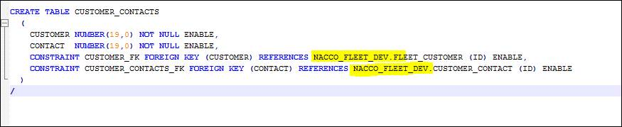

1. When you copy the DDL do not include the tablespace , pct free , inittrans , etc values (highlighted in the below screenshot)Reason: Oracle will auto allocate these values on new schemas. 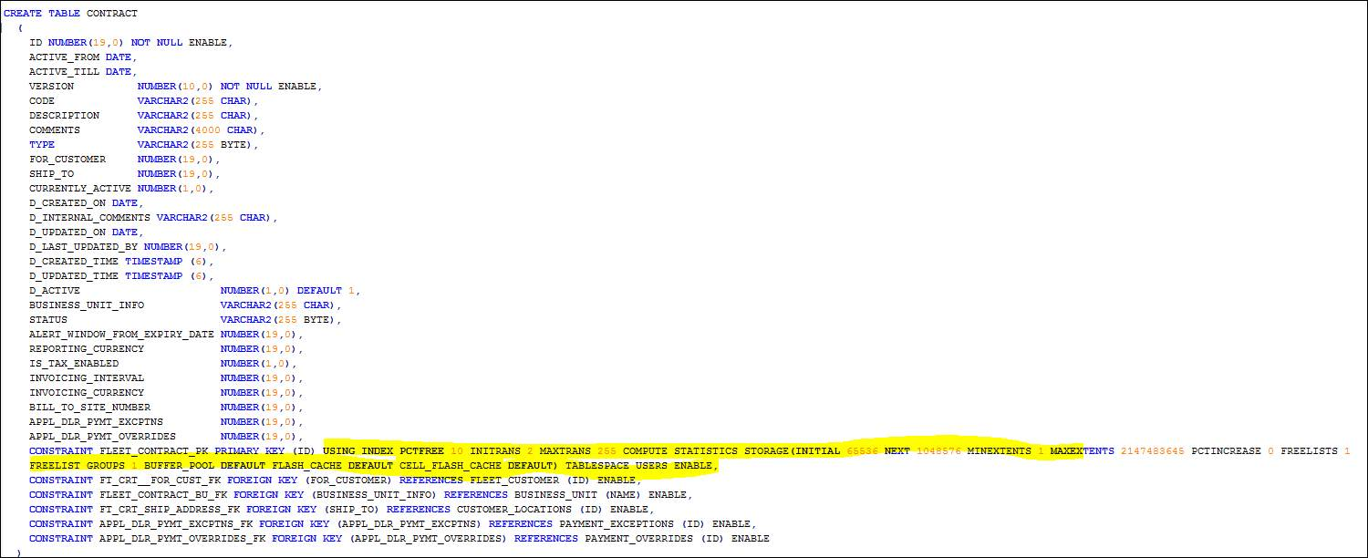

1. Include creation of foreign keys in a separate DDL .sql file but can be in the same ticket.

Reason: It is quite often seen that foreign key references to a table rasied in one ticket is not yet created since the ticket which creates the referencing table comes later in the ticket list.

                E.g.

CREATE TABLE CUSTOMER_LOCATIONS

(

    CUSTOMER                     NUMBER(19,0) NOT NULL ENABLE,

    LOCATIONS_MAPKEY             VARCHAR2(255 CHAR),

    ID                           NUMBER(19,0) NOT NULL ENABLE,

    QUOTE_THRESHOLD_AMT          NUMBER(19,2),

    QUOTE_THRESHOLD_CURR         VARCHAR2(255 CHAR),

    DEALER_QUOTE_VARIANCE        NUMBER(19,2),

    VARIANCE_IN_PERCENTAGE       NUMBER(1,0),

    CREATE_SERVICE_REQUEST       NUMBER(1,0),

    PERIODIC_SERVICE_CALL        NUMBER(1,0),

    ETA_ON_SERVICE_REQUEST       NUMBER(1,0),

    SELF_DIAGONOSIS_ENABLED      NUMBER(1,0),

    UPDATE_OPEN_SERVICE_REQUEST  NUMBER(1,0),

    SELF_DIAGNOSIS_MANDATORY     NUMBER(1,0),

    PURCHASE_ORDER_REQUIRED      NUMBER(1,0),

    DUPLICATE_PO_NUMBER_ALLOWED  NUMBER(1,0),

    PO_LENGTH_SPECIFIED          NUMBER(1,0),

    PURCHASE_ORDER_LENGTH        NUMBER(2,0),

    PO_REGULAR_EXPRESSION        VARCHAR2(255 CHAR),

    PO_DETAILS                   VARCHAR2(255 CHAR),

    CUSTOMER_NOTES               VARCHAR2(255 CHAR),

    IS_ACTIVE                    NUMBER(1,0),

    CODE                         VARCHAR2(255 CHAR),

    SPECIAL_INSTRUCTIONS         VARCHAR2(255 CHAR),

    CONSTRAINT CUSTOMER_LOCATIONS_PK PRIMARY KEY (ID) ENABLE,

~~CONSTRAINT CUSTOMERLOCATIONS_CUSTOMER_FK FOREIGN KEY (CUSTOMER) REFERENCES FLEET_CUSTOMER(ID) ENABLE,~~

~~CONSTRAINT CUSTOMER_LOCATIONS_ID_FK FOREIGN KEY (ID) REFERENCES ORGANIZATION (ID) ENABLE~~

  )

The foreign key constraint creation needs to go into a sepearate .sql file with the below contents , but in the same ticket.

ALTER table CUSTOMER_LOCATIONS add CONSTRAINT CUSTOMERLOCATIONS_CUSTOMER_FK FOREIGN KEY (CUSTOMER) REFERENCES FLEET_CUSTOMER(ID) ENABLE,

ALTER table CUSTOMER_LOCATIONS add CONSTRAINT CUSTOMER_LOCATIONS_ID_FK FOREIGN KEY (ID) REFERENCES ORGANIZATION (ID) ENABLE

1. Unit test any patch before raising a ticket for it and undo the action. This will eliminate any possible errors which may not be visible to the naked eye.

# **Patch filename guidelines:**

* Patch file name to start with the ticket number e.g. **NADB2-1.**
* Next, suffix DML patch names with ‘_DML’ and DDL patch names with ‘_DDL’ . Separate Patches for DMLs and DDLs  need to created , can be in the same ticket however e.g. NADB2-1**_DDL**
* Next , provide appropriate/meaningful names for patch files(file name not to exceed 55 characters and WITHOUT spaces) e.g. NADB2-1_DDL_REFR_ **PATCH_FOR_CREATING_TABLE_CUSTOMER_LOCS**
* File to be of sql file type (i.e. with '.sql' extension). . e.g. NADB2-1_DDL_REFR_ PATCH_FOR_CREATING_TABLE_CUSTOMER_LOCS**.sql .** Please do note that .sql must be in lower case